Library Database – SQL Project

Anees Rehman

**Business Process Modeling**

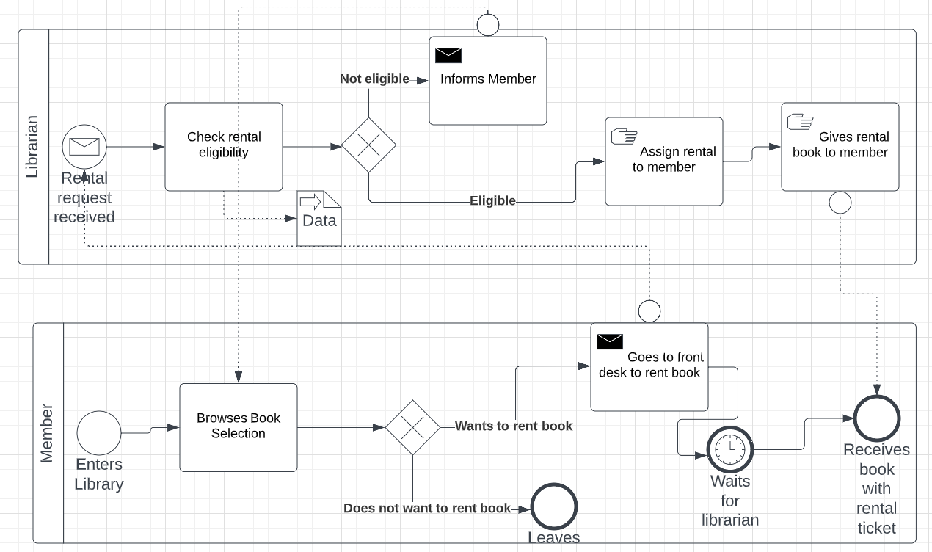

*Figure 1: Business Process model*

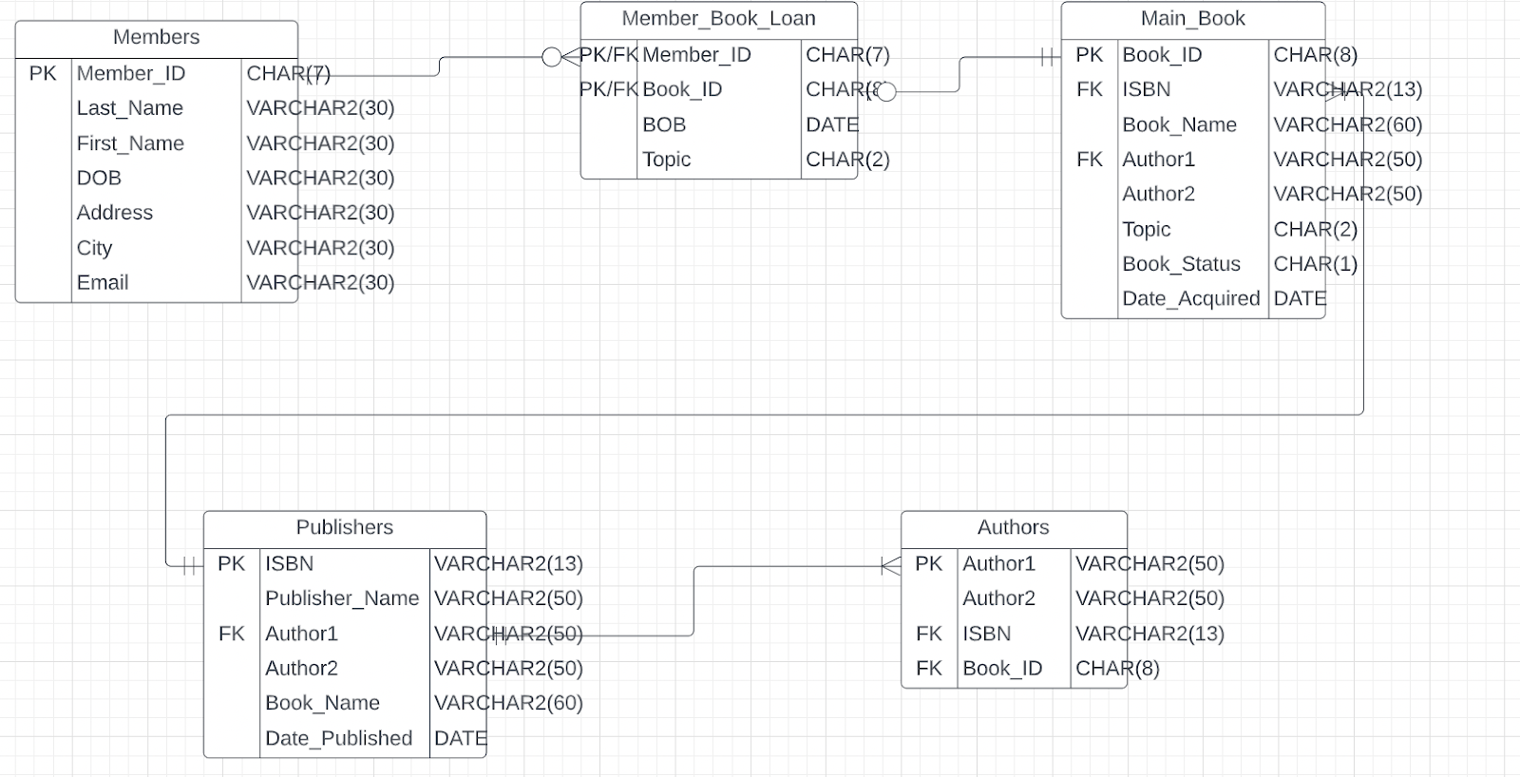

*Figure 2: Business ERD*: *relationship between entities*

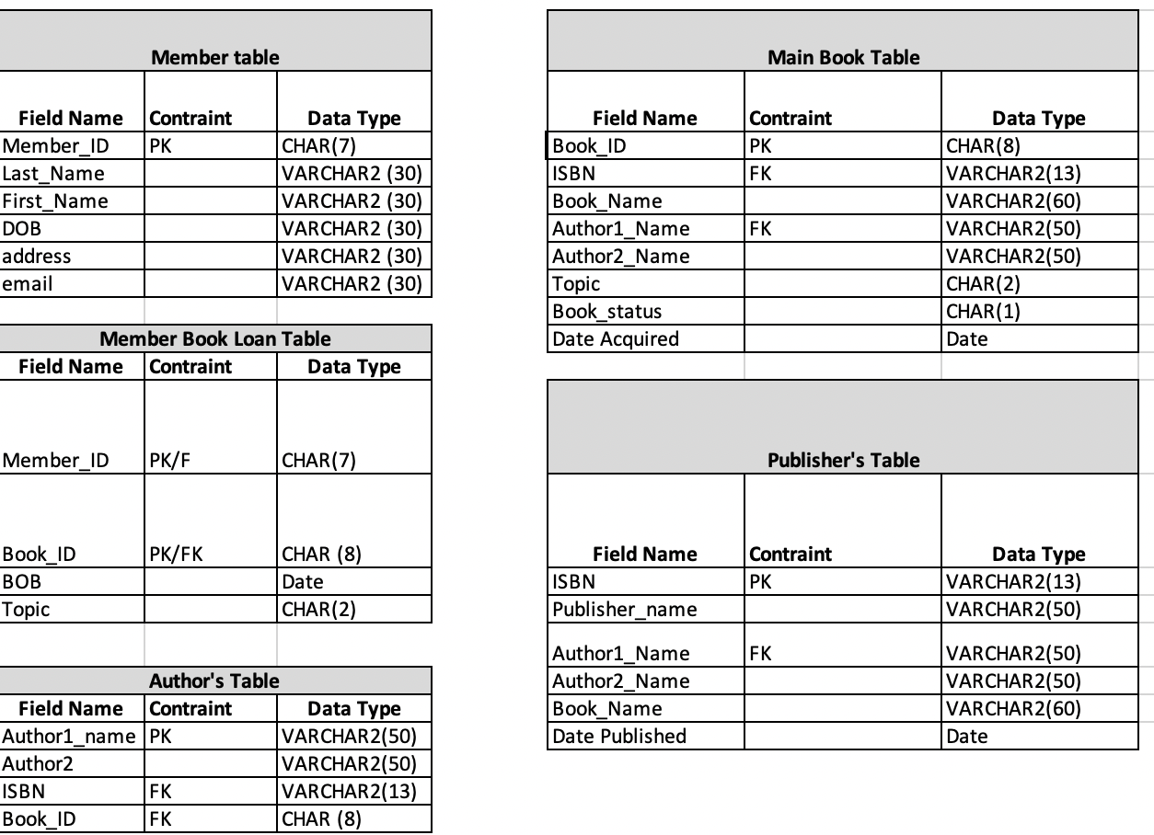

*Figure 3: The Data Dictionary*

**SQL Statements and Their Output**

The following are the SQL statements I used to create each of the five tables in the Oracle database.

CREATE TABLE "Members" (

"Member_ID" CHAR(7),

"Last_Name" VARCHAR2(30),

"First_Name" VARCHAR2(30),

"DOB" VARCHAR2(30),

"Address" VARCHAR2(30),

"City" VARCHAR2(30),

"Email" VARCHAR2(30),

PRIMARY KEY ("Member_ID")

);

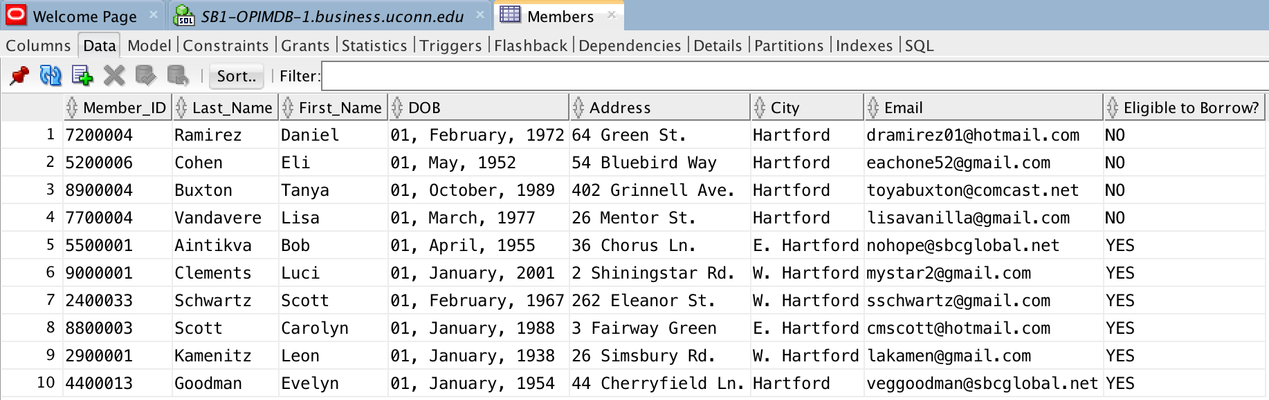

CREATE TABLE "Authors" (

"Author1" VARCHAR2(50),

"Author2" VARCHAR2(50),

"ISBN" VARCHAR2(13),

"Book_ID" CHAR(8),

PRIMARY KEY ("Author1")

);

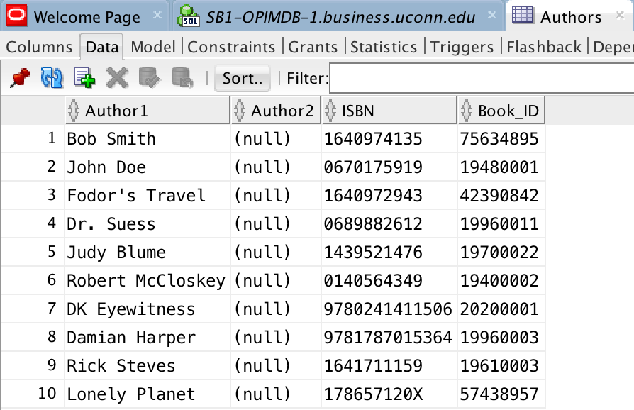

CREATE TABLE "Publishers" (

"ISBN" VARCHAR2(13),

"Publisher_Name" VARCHAR2(50),

"Author1" VARCHAR2(50),

"Author2" VARCHAR2(50),

"Book_Name" VARCHAR2(60),

"Date_Published" DATE,

PRIMARY KEY ("ISBN"),

CONSTRAINT "FK_Publishers.Author1"

FOREIGN KEY ("Author1")

REFERENCES "Authors"("Author1")

);

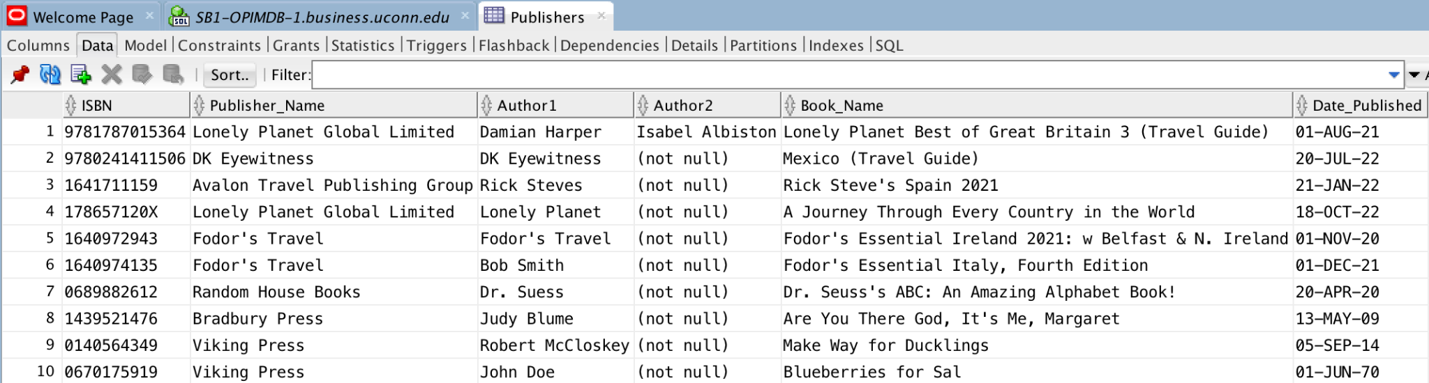

CREATE TABLE "Main_Book" (

"Book_ID" CHAR(8),

"ISBN" VARCHAR2(13),

"Book_Name" VARCHAR2(60),

"Author1" VARCHAR2(50),

"Author2" VARCHAR2(50),

"Topic" CHAR(2),

"Book_Status" CHAR(1),

"Date_Acquired" DATE,

PRIMARY KEY ("Book_ID"),

CONSTRAINT "FK_Main_Book.ISBN"

FOREIGN KEY ("ISBN")

REFERENCES "Publishers"("ISBN")

);

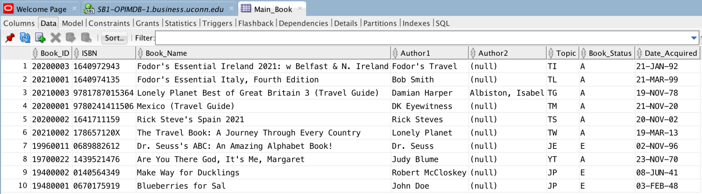

CREATE TABLE "Member_Book_Loan" (

"Member_ID" CHAR(7),

"Book_ID" CHAR(8),

"BOB" DATE,

"Topic" CHAR(2),

CONSTRAINT "FK_Member_Book_Loan.Member_ID"

FOREIGN KEY ("Member_ID")

REFERENCES "Members"("Member_ID")

);

CREATE INDEX "PK/FK" ON "Member_Book_Loan" ("Member_ID", "Book_ID");

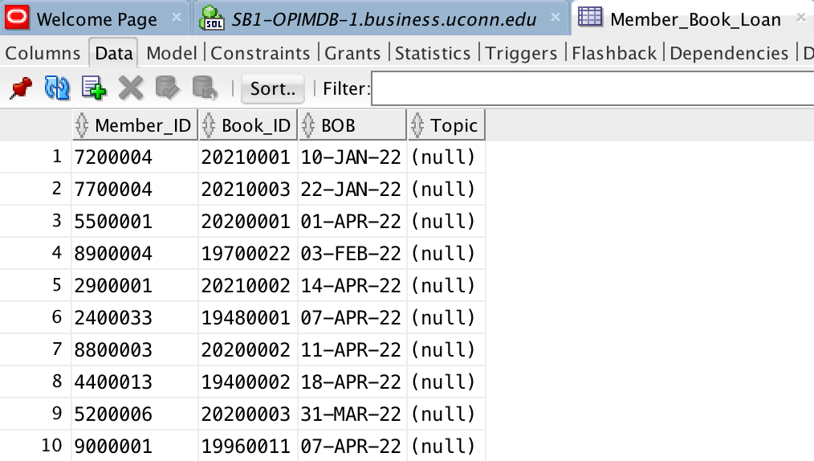

**SQL Reports**

Once I created the tables in Oracle and imported all the required data into each of the tables in Oracle, I generated reports to solve different library queries.

---**Report 1: Library Member Borrow Status**---

select "Member_ID",

case when "BOB" >= '14-APR-22' then 'Recent Check Out'

when "BOB" >= '01-Apr-22' then 'Due Soon'

else 'Overdue' end "Member Overdue Status"

from "Member_Book_Loan";

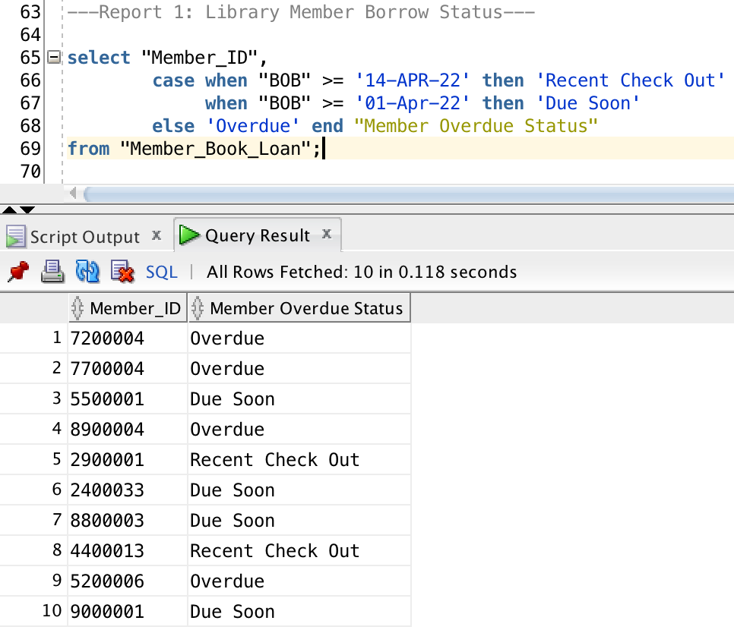

In this report, the librarian would be able to see library members’ borrowing status. This allows the librarian to understand which members may have overdue books and/or books due soon, so they can send out return reminders.

---**Report 2: Average Age of Library Members**---

select "DOB",

round(months_between(sysdate, "DOB") / 12, 0) as "Age",

round(avg(months_between(sysdate, "DOB") / 12) over(), 0) as "Average Age"

from "Members";

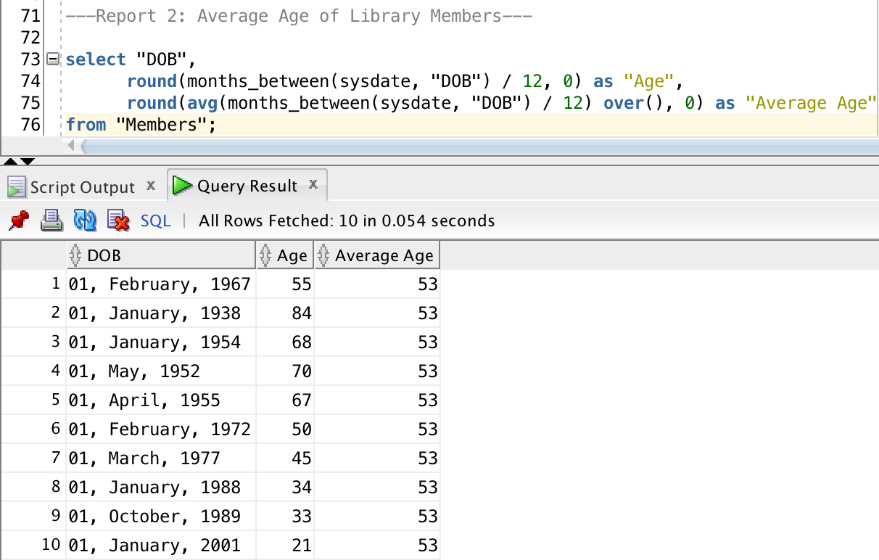

This report shows the library what the average age of their members is. This insight allows the library to cater/tailor their social events to this age group.

---**Report 3: Library Member Borrow Eligibility**---

alter table "Members" add "Eligible to Borrow?" varchar2(3);

update "Members" set "Eligible to Borrow?" = 'YES' where "Member_ID" in (select "Member_ID" from "Member_Book_Loan" where "BOB" > '31-MAR-22');

update "Members" set "Eligible to Borrow?" = 'NO' where "Member_ID" in (select "Member_ID" from "Member_Book_Loan" where "BOB" <= '31-MAR-22');

SELECT * FROM "Members";

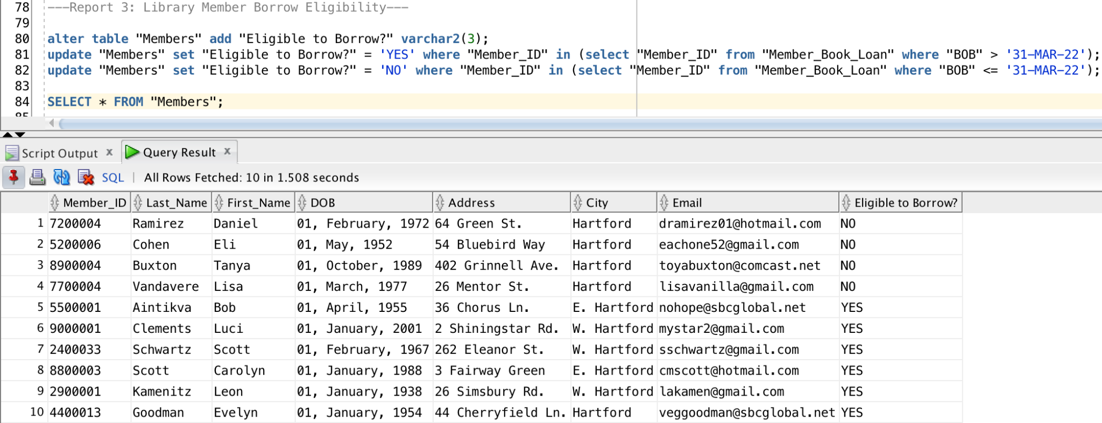

This report offers more insight into the library members while also providing borrow eligibility, based on any overdue books and/or pending fines. For example, if a member is trying to borrow a book despite having overdue fines, the librarian will know not to loan out any more books to this individual until their fines are paid off.

---**Report 4: Pairing Publisher Name with Book Name and Book ID Number**---

select "Publisher_Name", "Book_Name", "Author1", "Book_ID"

from "Authors" join "Publishers" using ("Author1");

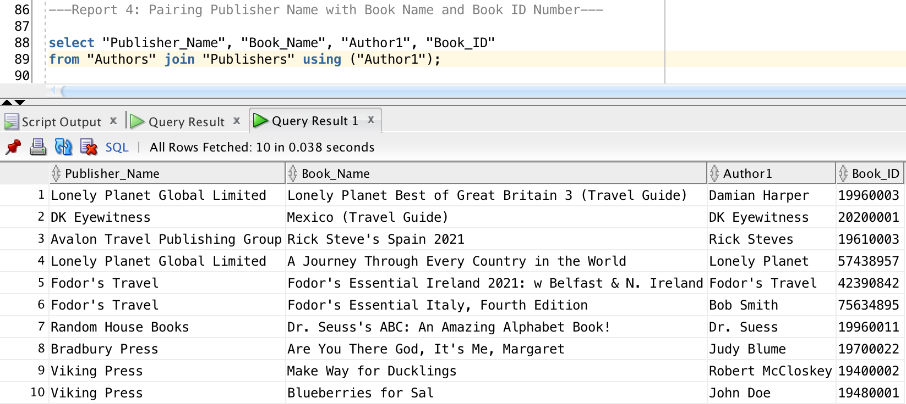

This report shows which publishers are associated with each book. This allows libraries to diversify their book collection.

---**Report 5: Setting Book Status to Exempt for Children's Books**---

update "Main_Book" set "Book_Status" = 'E' where "Topic" = 'JP' or "Topic" = 'JE';

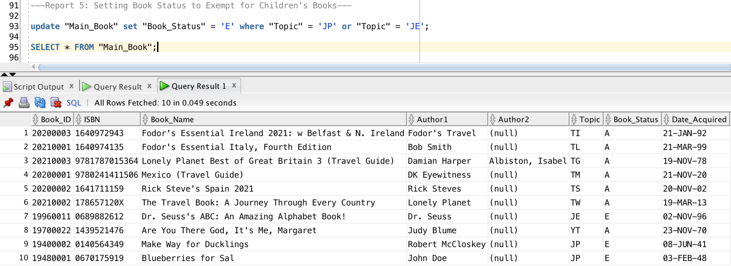

This report shows which books are rented out to children and are therefore exempt from overdue fines.

---**Report 6: Identifying Overdue Books-**--

select "Book_Name" as "Overdue Books" from "Main_Book" where "Book_ID" in (select "Book_ID" from "Member_Book_Loan" where "BOB" <= '31-MAR-22');

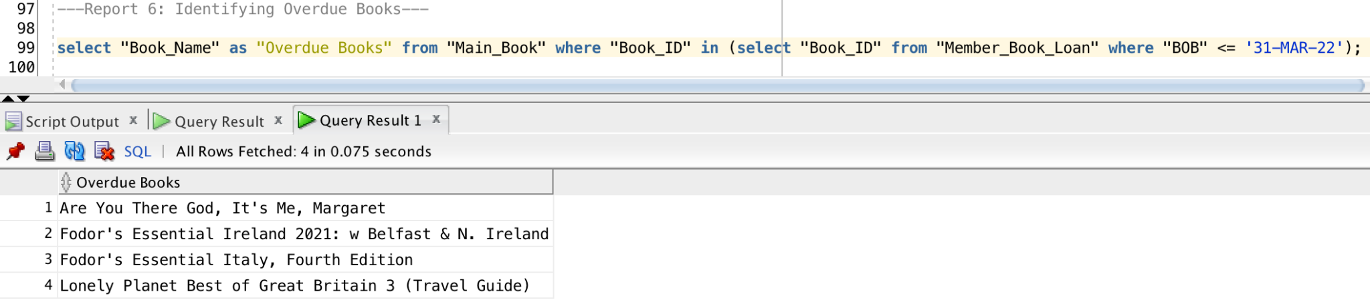

.

This report offers insight into which books are overdue so the library knows what it needs to keep tabs on/send out return reminders. This also serves as a reminder for librarians to impose fines.

---**Report 7: Identifying Travel Books Owned by the Library**---

select "Author1", "Book_Name" from "Main_Book" where "Topic" like 'T%';

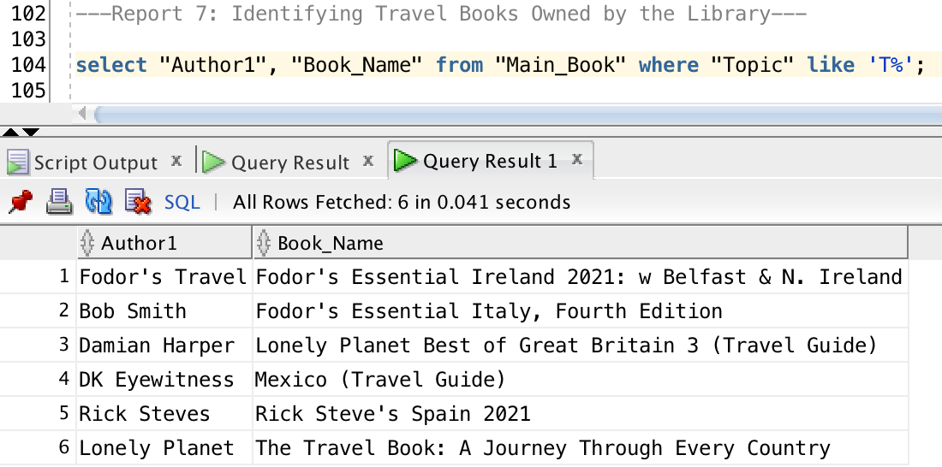

This report shows which travel books the library currently owns. This is an example, but if an individual came in asking “what (insert genre) books do you have,” this report could be run to quickly provide an answer.

---**Report 8: Identifying Members From Our Library's Location, Hartford**---

select CONCAT(CONCAT("First_Name", ' '), "Last_Name") as "Hartford Residents" from "Members" where "City" = 'Hartford';

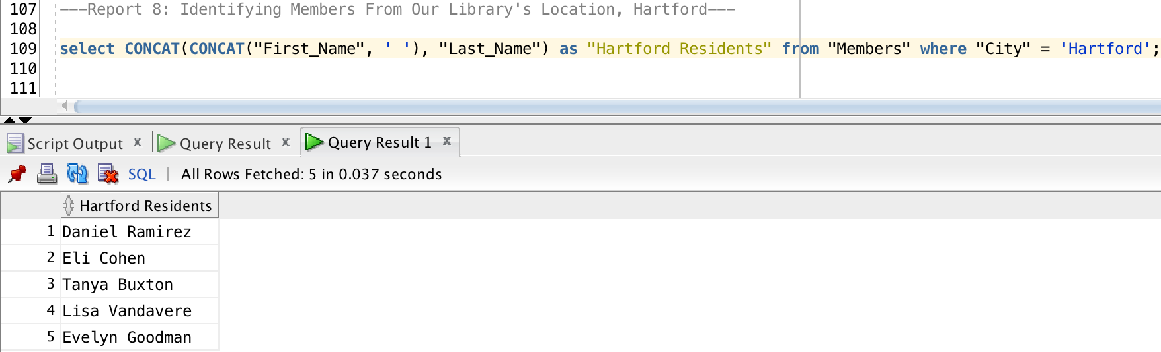

This report identifies the local members of the Hartford library (i.e. those that live in Hartford). This could be valuable information, as sometimes local members are given lengthier rental periods/longer grace periods for fines.

---**Report 9: Calculating Average Rental Length-**--

select trunc(sysdate) - to_date("BOB", 'dd-mon-yy') as "Days Borrowed", "Book_Name", "Book_ID" from "Member_Book_Loan" join "Main_Book" using ("Book_ID");

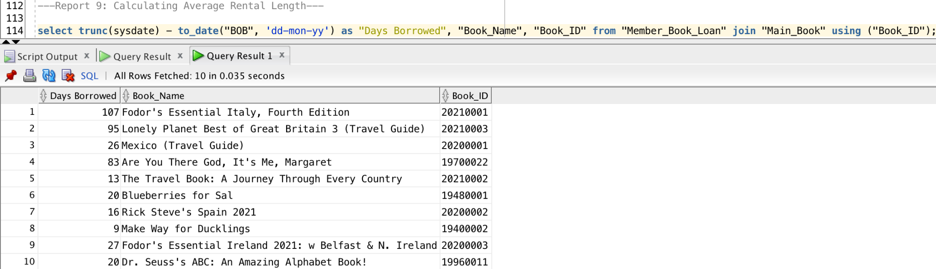

This report shows the calculated average number of days that each book is rented for. This could be insightful so the library knows to acquire additional copies of books that are rented for longer periods of time, as to ensure minimal wait times for those interested in renting out those books.